Practical 8
Code:https://github.com/bhavyakumar18/DSA/tree/main/Practical%208
Problem 1, I faced difficulty understanding the four types of binary tree traversals: inorder, preorder, postorder, and level order. I solved this problem by using recursion for the first three traversals and a queue for level order traversal. I tested the program with sample inputs to verify the output.
Output:
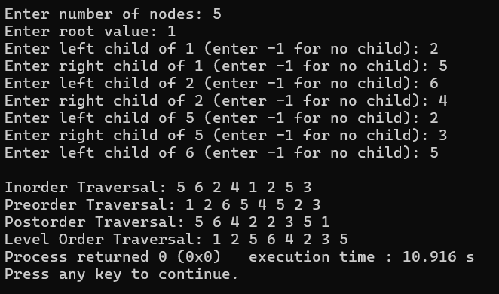
Problem 2, I faced difficulty inserting book codes into the correct positions in a Binary Search Tree and displaying them in ascending order. I solved this problem by inserting smaller values into the left subtree and larger values into the right subtree. Finally, I used inorder traversal to display the book codes in ascending order and checked the output.
Output:
